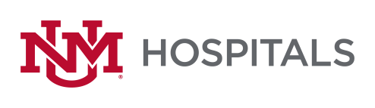

To: All Potential Offerors
From: Sherry Tackett, Procurement Specialist
Date: 2/7/2023
Subject: RFP# P479-23 Interventional Radiology Neuroendovascular Implants & Disposables
Addendum: # 1
Please add this Addendum # 1 to the original RFP documents. It shall be the responsibility of the interested Offerors to adhere to any changes or revision to the RFP as identified in this Addendum.

The following clarification shall become permanent and made part of the procurement file.

- The opening date has been extended to March 1, 2023 @ 2:00 PM MST

If there are any questions or inquiries in relation to this Addendum #1, Offerors may contact Sherry Tackett by email at sltackett@salud.unm.edu.

